Who are we?
Earth Wise Consulting is your choice for: grant writing, project development, project implementation services, project management, and general consulting. We are life jackets to our clients—giving them the protection and peace of mind to weather troubled waters. Many consultants focus on taking your money; we focus on helping you find ways to capitalize on available programming, and keep your money so you can invest in what is important to you—your people and your business. We work with diverse groups ranging from small businesses and moderate-sized businesses to municipalities to non-profits. We’ve helped our clients receive: local, state, federal, and philanthropic funds. We have more than 10 years experience in project funding and project management.

Our clients received nearly $2.5M in American Reinvestment and Recovery Act (ARRA) funding.

How can we help?
At Earth Wise Consulting we partner, and we pride ourselves in doing so. We keep our costs down by utilizing a network of subcontractors that can assist with: surveying; structural, civil, and transportation engineering; geo-technical services; solar; geothermal; LEED-certification; and professional lobbying. Our clients appreciate our ability to take concepts and turn them into realities—no matter how complex the issue.

What do our clients say?
Ken Tewell, Owner Everett Hardwoods Business Park:
"Earth Wise Consulting has assisted me with being a better neighbor. They procured grant funds that helped me remove hazardous chemicals, address blight, and are now assisting me with completing a redevelopment plan. They've even managed to obtain funds for stormwater upgrades. I can't say enough good things about them. Best of all, their services are very affordable."

John Dawes, Executive Director Foundation for Pennsylvania Watersheds:
"Branden S. Diehl is a pleasure to work with. He has a keen sense of how projects work, how to integrate project pieces, and is a master at knowing where the money is coming from--often times before even agency folks know.”

Carl Michael, Everett Borough President:
"I'm not sure how they do it, but they perform. Their redevelopment assistance has helped address blight concerns, and provided hope for a more stable tax-base via redeveloping a Brownfields Site."

Steve Smith, M.S. Smith Farm:
"We tell everyone about Earth Wise Consulting. They take ideas and morph them into projects; making it look easy.”

Paul Bunker, Chief Finance Officer Hyndman Area Health Center:
“Earth Wise has been exactly what we were looking for. Prior consultants were overpriced and underperformed. Thanks to Branden’s business we are looking forward to opening a facility that is more than 10 times the size of our current Bedford location.”

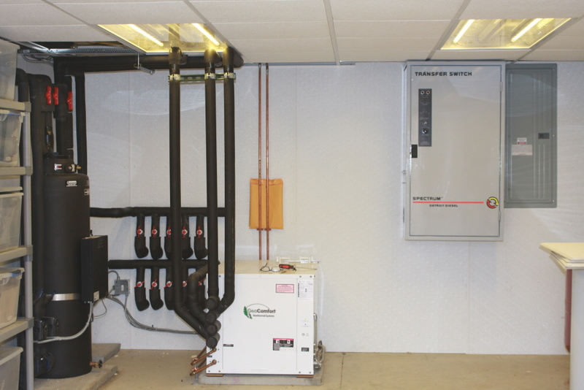
Sampling of Green Projects:
Southern Alleghenies Conservancy, Bedford PA
$98,000 for a regional biomass study.

Huntingdon Farm, Huntingdon, PA
$35,000 grant for a Bergey 10kW wind system (state funding).

Community Foundation for Alleghenies (grant sponsor), Bedford, PA
$199,000 for solar, wind, insulation, and geothermal system (state funding).

MS Smith Farm, Martinsburg PA
$50,000 tax-credit program for innovative manure management project (state tax program).

Everett Hardwoods Business Park, Everett, PA.
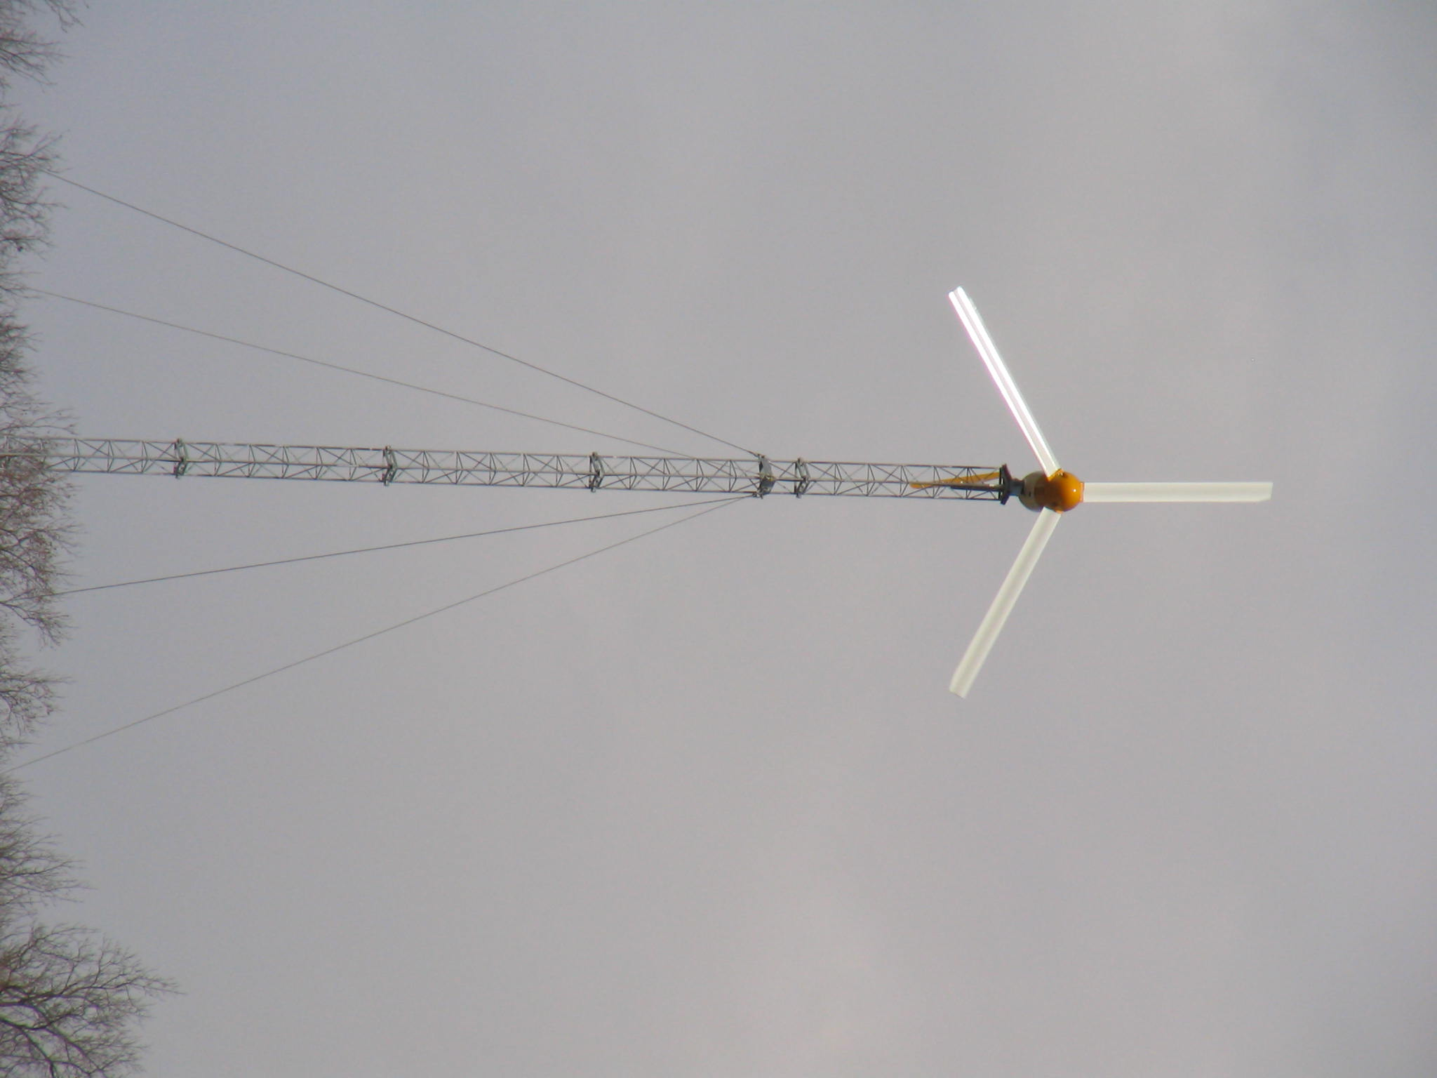
$18,000 for energy saving lighting (electric rebate program).
Friendship Vol. Fire Department, Roaring Spring, PA.
$2,500 to $3,500 for energy saving lighting (electric rebate program).

Everett Hardwoods Business Park, Everett, PA.
$150,000 innovative stormwater management for drying basement and enhancing water quality (ARRA).

Six Mile Run Vol. Fire Department, Six Mile Run, PA.
$2.2 LEED-certified fire station construction (ARRA).
$40,000 innovative stormwater system for rain capture (ARRA).

Hyndman Area Health Center, Bedford, PA.
$20,000 for LEED certification on $1.25M renovation project (philanthropic). $300,000 state grant for energy efficiency upgrades (pending).

Thank you for this opportunity for us to share our business with you. We hope to add you to our satisfied client list soon.
Regards,
B
Branden S. Diehl
CEO

